Manage Subscriptions and RBAC

Lab Overview
This lab explains how Azure controls access using Role-Based Access Control (RBAC) and Management Groups.
You learn how permissions flow from management groups down to subscriptions and resources.
Estimated Time: 20 minutes
Azure Region: East US
Core Services: Management Groups, RBAC, Activity Log

Lab Scenario
Your organization wants:
- Centralized management of multiple subscriptions
- Help Desk users to:
  - Manage virtual machines
  - Create support requests
- No permission to register Azure resource providers

Architecture diagram
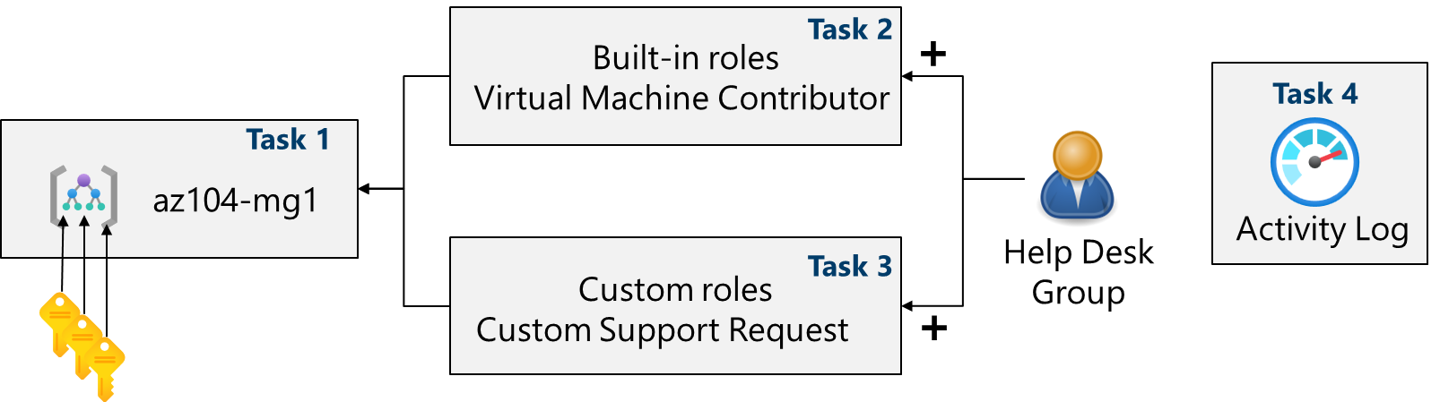

Job Skills Covered
- Implement Management Groups
- Assign Built-in RBAC Roles
- Create Custom RBAC Roles
- Monitor Access Changes using Activity Log

Task 1 – Implement Management Groups

Purpose
Management groups help organize subscriptions and apply RBAC and policies centrally.

Steps
- Sign in to https://portal.azure.com
- Search and open Microsoft Entra ID
- Select Properties
- Review Access management for Azure resources
- Search and open Management groups
- Select + Create

Configuration
Setting | Value
Management group ID | az104-mg1
Display name | az104-mg1
- Select Submit
- Refresh and verify creation

Important Note – Root Management Group
- Automatically created
- Parent of all management groups and subscriptions
- Used for global policies and RBAC

Task 2 – Review and Assign a Built-in Azure Role

Purpose
Grant the Help Desk permission to manage virtual machines at the management group level.

Steps
- Select az104-mg1
- Go to Access control (IAM) → Roles
- Review built-in roles (Owner, Contributor, Reader)

Assign VM Contributor Role
- Select + Add → Add role assignment
- Choose Virtual Machine Contributor
- Select Next
- Select Members
- Choose Help Desk group
- Select Review + assign (twice)

Verification
- Go to Role assignments
- Confirm Help Desk group has Virtual Machine Contributor

Best Practice
- Always assign roles to groups, not individuals
- Permissions assigned at management group level are inherited

Task 3 – Create a Custom RBAC Role

Purpose
Implement least privilege by limiting Help Desk permissions.

Steps
- Stay in az104-mg1 → Access control (IAM)
- Select + Add → Add custom role

Basics Tab
Setting | Value
Name | Custom Support Request
Description | Custom contributor role for support requests
Baseline permissions | Clone a role
Role to clone | Support Request Contributor

Permissions Tab
- Select + Exclude permissions
- Search resource provider: Microsoft.Support
- Exclude:
  - Register Support Resource Provider
- Select Add

Assignable Scopes
- Ensure az104-mg1 is selected
- Select Next

Review and Create
- Review JSON (Actions, NotActions, AssignableScopes)
- Select Review + Create
- Select Create

Task 4 – Monitor Role Assignments with Activity Log

Purpose
Audit changes to access and role assignments.

Steps
- Open az104-mg1
- Select Activity log
- Filter for:
  - Role assignment events
  - Role creation events

Cleanup (Optional)
Delete management group to avoid clutter.

Portal
- Select az104-mg1 → Delete

PowerShell
Remove-AzManagementGroup -GroupName az104-mg1

Azure CLI
az account management-group delete --name az104-mg1

